TASK 1 – TABLE WITHOUT INDEX
For correct results we need to set no run parallel process (because every time can run multiple parallel process).
What I got with ‘explain’ is same result for checking plan twice. Result is same
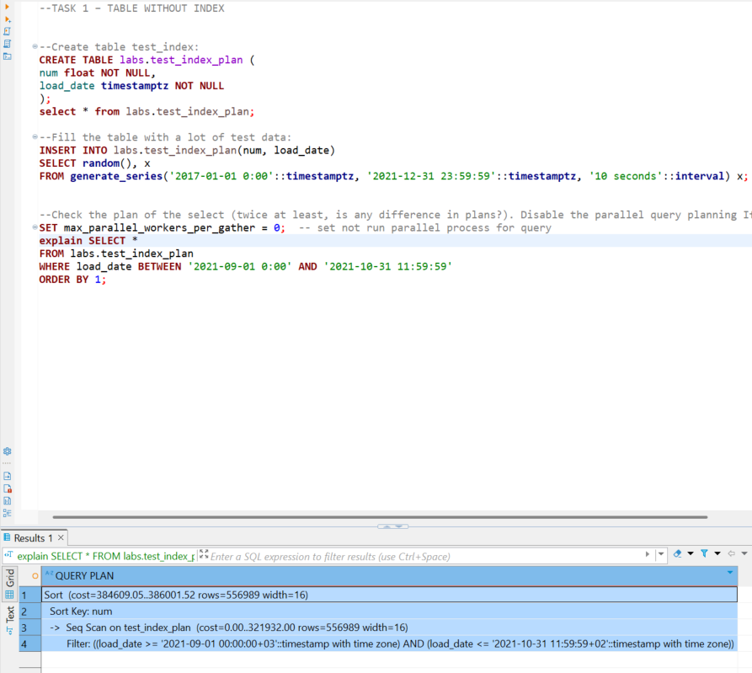
Analyze add statistics in plan about running time. When I use explain analyze I get more Query plan rows like :
- planning time: 0.077 ms
- execution time: 1150.234 ms
when I use explain analyze second time execution time a little bit changing . This is normal. We use here random() function so time can be quicker and not. If we don’t have random function I think we have second result always quicker, because we have caching effect (first time it is read from disk and second time from RAM)
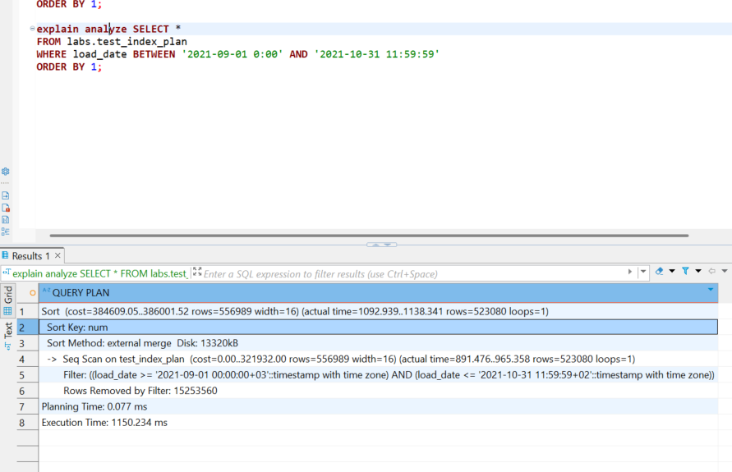
When we run explain (analyze, buffers) we get information about how many pages we from caching pages and how much from disk (some operation need to connect to disk always)
In results “ Buffers: shared hit=16211 read=69069, temp read=1665 written=1672” we see that 16211 buffer pages from RAM and 69069 from disk
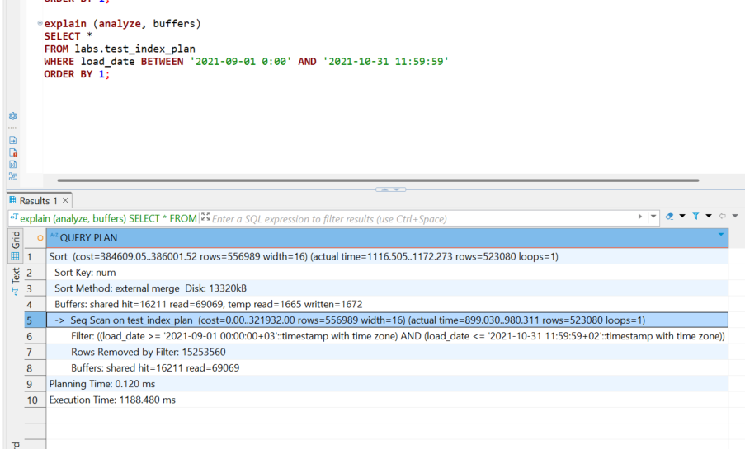
So we have always changing time, others values are same. Time can change by many parametrs, especially from: caching, disk I/O and system resources. First run of a query may have higher execution time due to data not being cached, whereas the second run might be faster because the data is already in memory.
TASK 2 – ADDING INDEX
Using Explain … running with b-tree index cost is more than 4 time lower 384609/82942 ~ 4.6 x
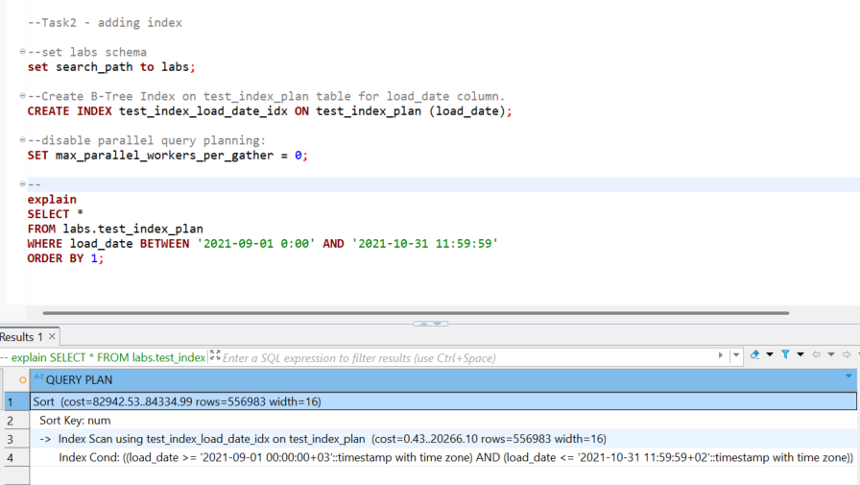

Using Explain analyze … with b-tree index execution time more than 4 times lower 😊
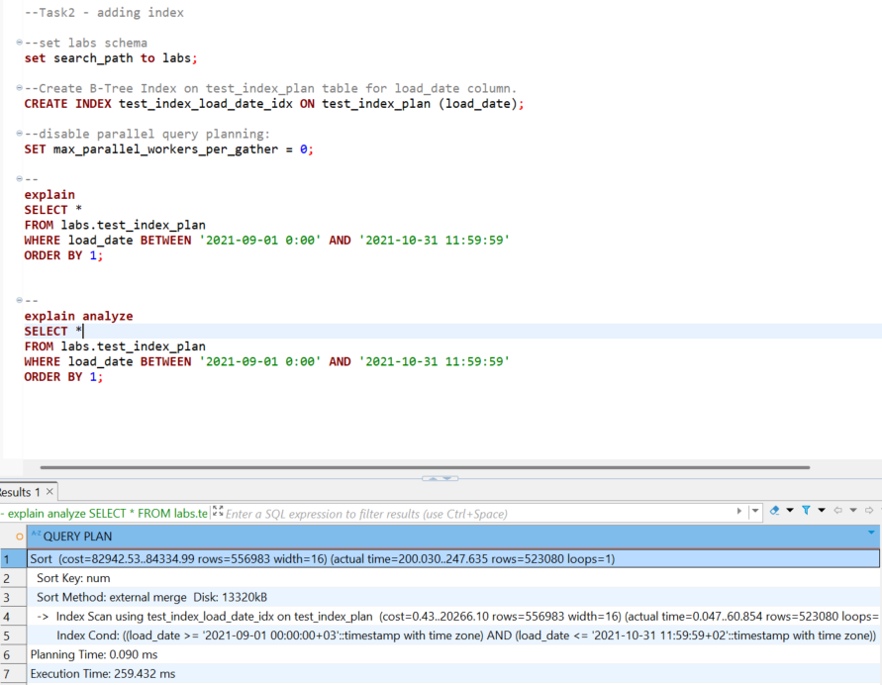

Using explain analyze, buffers . Shows additional how much values are readed from cash and disk … with b-tree index execution time more than4 times lower 😊
Results without b-tree index : hit=16211, read=69069
Results without b-tree index : hit=4260, read=1665

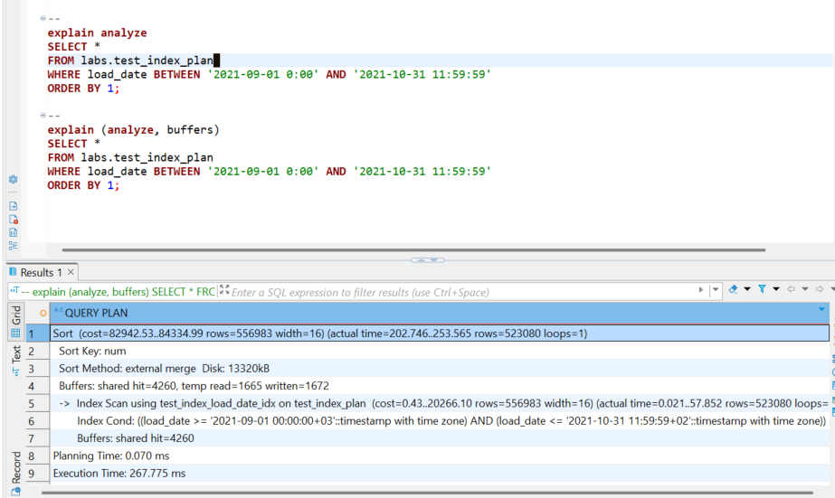

Ok when I create index only scan that mean Postgre don use table only index (I use index on all table colums)
-- Use INDEX ONLY SCAN method;
CREATE INDEX idx_load_date_num ON labs.test_index_plan (load_date, num);

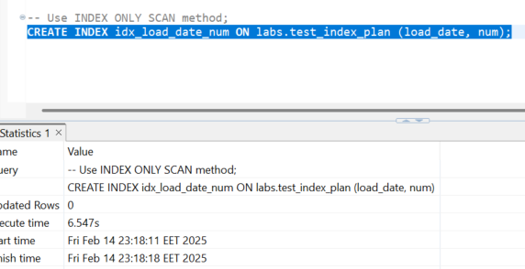

Using Index Only Scan a little bit cost is less 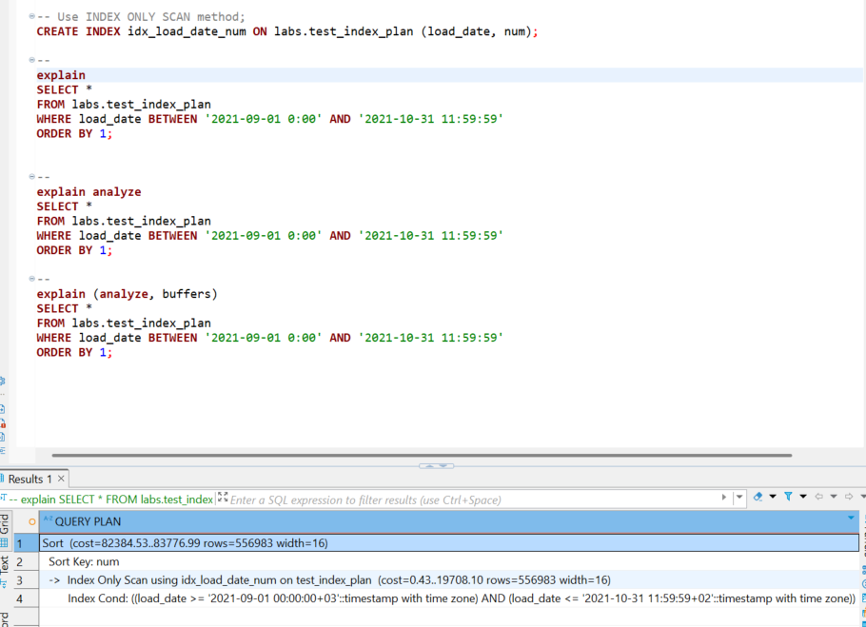
Same with time when using index only scan
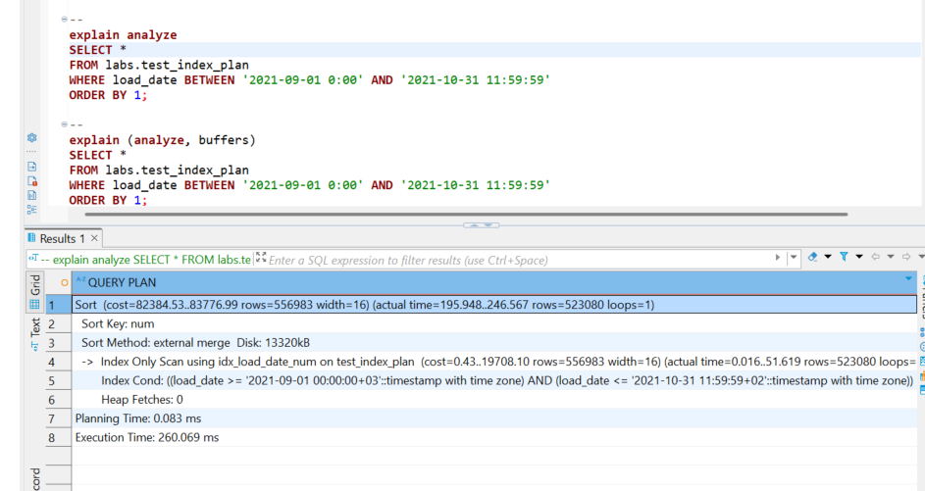

Dramaticaly lower hit In
Results without b-tree index : hit=16211, read=69069
Results without b-tree index : hit=4260, read=1665
Results with Index only scan : hit=2009, read= 1665

